Calculus 1 Lecture 4.3: Area Under a Curve, Limit Approach, Riemann Sums

Area as a limit
Sigma Notation 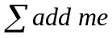
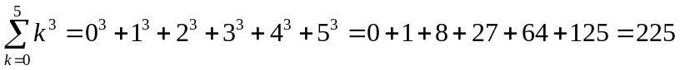

Properties:
- 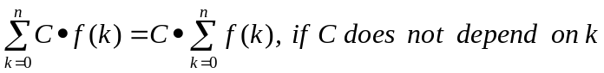
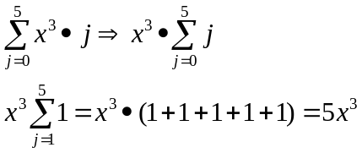
- 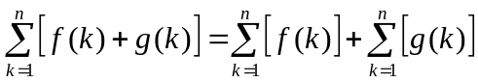

Formulas
- 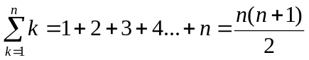
- 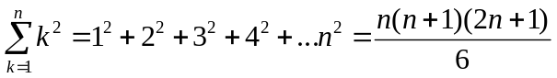
- 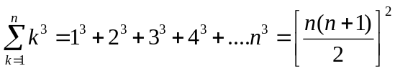
- 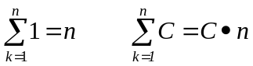

Example
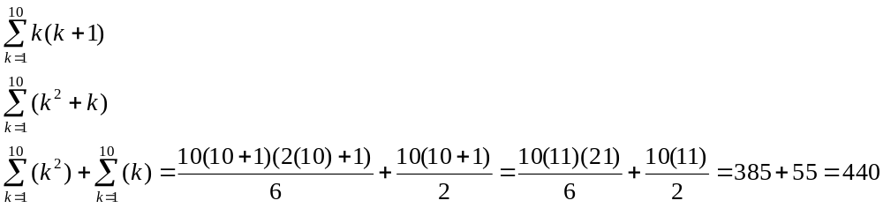

Area
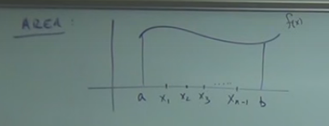

Cut area into “n” equal sub-sections.
The width of each interval is 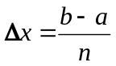
Pick an arbitrary point for each sub-interval and make a rectangle

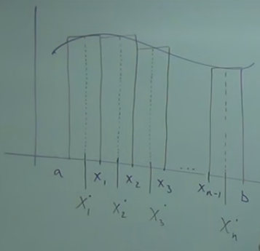

Height of each rectangle.
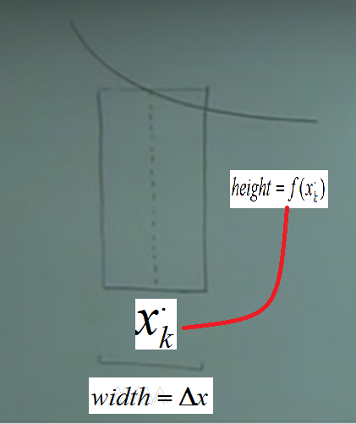

Width = 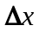
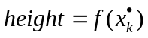
Height of each rectangle is = 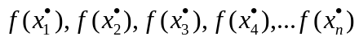
Area of a rectangle is 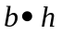
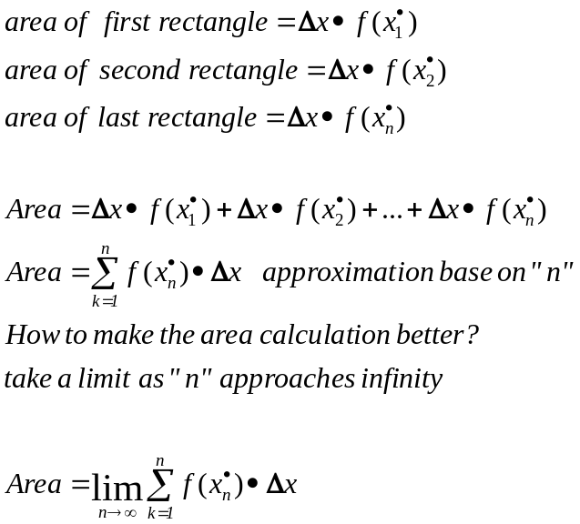

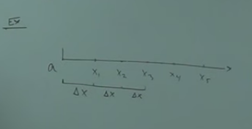

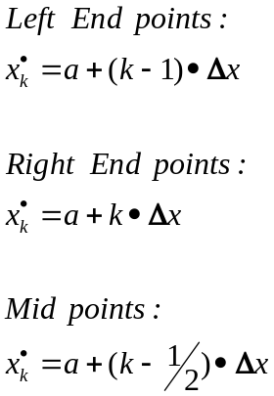

Example
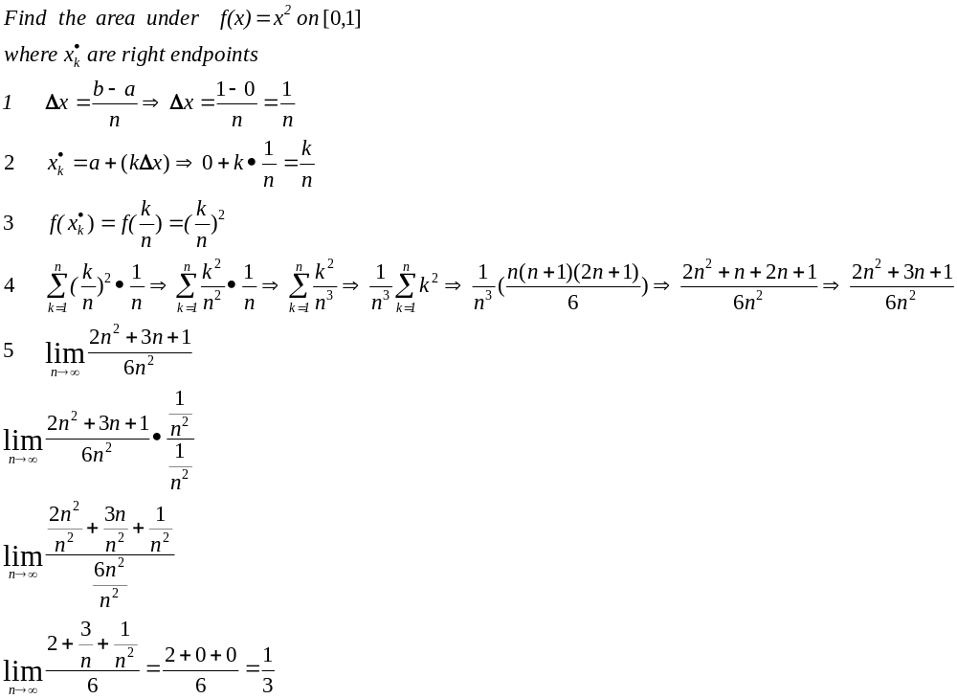

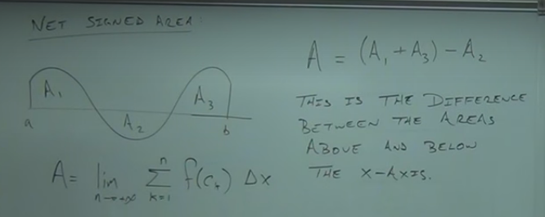

Example
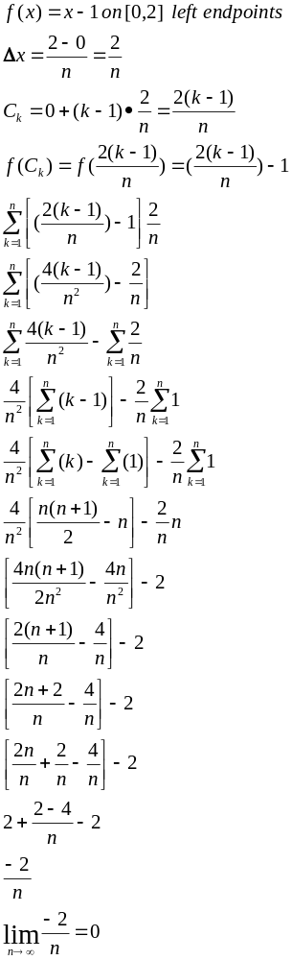

Example
